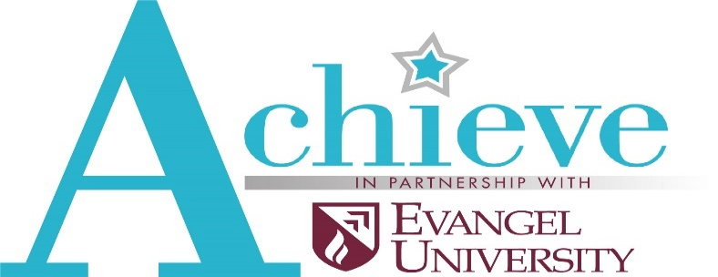____________________________________________________________________________________

Achieve in partnership with Evangel University
Achieve of Southwest Missouri is a local 501(c)3 nonprofit organization that provides comprehensive transition services to individuals with disabilities in Southwest Missouri who need additional skills and supports to succeed in life after high school. Primarily for ages 18-25, achieve will provide instruction and experiences in life management, career exploration, and self-determination. ______________________________________________________________________________

Admission Guidelines
- Primarily for individuals between the ages of 18-25
- Express desire and motivation to complete a post-secondary transition program and secure employment or further their education upon completion.
- Demonstrate active participation throughout the application/interview process
- Demonstrate the ability to communicate with staff, faculty, and peer mentors.
- Motivation to function independently and to practice navigating campus independently
- Sufficient emotional and independent stability to participate in all aspects of the Achieve program and campus life.
- Able to be successful in competitive employment with reasonable accommodations
- Have proof of health insurance (Medicaid, Medicare, private)

Application Specifics
Necessary information requested in the application
- Student information (including Education Background and Employment History)
- Parent/Guardian information
- Medical Information and History Form
- Release/Exchange of Information
- Transcripts
- Three Letters of Recommendation from the following areas; Personal Reference, Educational Reference, Vocational/Employment Reference, Community Reference.
- Copies of additional reports:
  - Applicant’s most recent IEP and/or 504 Plan
  - Copy of Summary of Performance, if available
  - Copy of recent Individual Service Plan (ISP) if applicable
- Educational Evaluations conducted within the last three years (if applicable), such as:
  - School re-evaluation
  - Peabody Individual Achievement Test
  - Kaufman Test of Educational Achievement
- Copy of recent (within the last year) Functional Behavioral Assessment, if applicable

Application
Application Timeline for School Year 2021-2022
- Admission applications available at www.achieveswmo.com
- Friday, March 25, 2021 – Applications Due to Achieve
- April 2021 – Student interviews
- Friday, May 7, 2021– Notification of program acceptance
- August 2021 – Classes Begin

A minimum of 4 students will be accepted for our first class of 2021-2022. Students will spend at least two days on campus attending class, working on personal goals with peer mentors, and spending time in vocational experiences. Typically Friday’s class will be spent in the community practicing life management skills.
A $25 non-refundable application fee must be included with each submitted application.
Achieve will follow the Evangel University holiday schedule and receive approximately 600 hours of personal instruction ____________________________________________________________________________

The Interview
- The applicant will first be interviewed, along with a parent(s)/guardian(s) who is familiar with the applicant’s current abilities. Questions will focus on:

- Why they want to attend this program
- What they expect to get out of the program
- Activities they want to participate in
- Prior work or school experiences
- Where they want to work and live
- Situational questions (what would you do if?)

- The applicant will take a tour of campus with a peer mentor while their parent(s)/guardian(s) is interviewed.
Parent(s)/Guardian(s) interview questions will focus on:

- Goals for the applicant attending the program
- Understanding the difference between high school and college
- Transportation plans
- Financial commitment
- Medical concerns
- Behavior concerns

- The applicant will return for a one-on-one interview (without a parent(s)/guardian(s) present). Questions will focus on:
- Vision for the future
- Perceived barriers to success
- Fears and concerns

Summaries of application and interview notes will then be provided to the Achieve Board of Directors, Admissions Committee. The Board Admissions Committee will make recommendations on whom to extend an invitation.
In some cases, candidates may be invited to spend half a day on campus, attending classes, and spending time participating in social activities. This opportunity will allow committee members to observe the student and make an informed decision.
The decision to offer or deny admission to the program will be made by the Achieve Board of Directors, Admissions Committee, and is made in their best judgment and the best interest of the applicant. Admission will be based on the criteria outlined before and the committee’s professional opinion about issues such as:
- The applicant’s desire to attend and succeed in the Achieve program
- The applicant’s willingness to adhere to the policies regarding attendance and participation
- The applicant’s potential to successfully achieve his or her goals
- The applicant’s ability to assimilate into the campus culture, accept and follow campus expectations and rules of the program.
  - Achieve does not have the personnel to:
    - supervise students with difficult or challenging behavior
    - dispense medication
    - provide personal assistance

Letters of acceptance will be sent to the top candidates on or after Friday, May 7, 2020.
Once an applicant receives an acceptance letter and accepts the invitation to Achieve, they are required to pay a $200 non-refundable deposit within 30 days of the acceptance letter to secure their place within the program.
The student tuition investment of $3,750 a semester is expected to be paid in full by the end of each semester and will include all campus fees including lunch on the days they are on campus. This equates to paying $12.50 per hour of person centered instruction on an evidence based curriculucm designed to build skills in life management, career exploration and self-determination.
Students will be asked to leave if they do not respect the policies and procedures of Achieve of Southwest Missouri or Evangel University.

